Final Project

car wash

SaHIBJOT singh

Table of Contents

Project Proposal 1

Project Introduction and Overview 1

Project Specifications 2

Project Goal 2

Scope 2

Project Specifications 2

Target Audience 2

Project Plan 2

Project Deliverables 2

Project Tasks and Milestones 3

Resources Required 3

Project Risks and Assumptions 3

Project Report 4

Aim and Introduction 4

Analysis 4

Functional and Non-Functional 4

Non-Functional 4

System Usability Testing 7

Testing 7

# Project Proposal

# Project Introduction and Overview

This project is based on the Carwash. In this ASP.net project there are one type of account is admin. admin can add, edit, delete, and access details. Admin can also edit, delete, and access details.

# Project Specifications

## Project Goal

The main goal of this project is to implement an online web application using Asp.Net. The name of this web application will be “CARWASH” . Admin can record details about bookings, type of services, pricing.

## Scope

The main goal of this application is to implement a CARWASH. This project is for 4 weeks.

# Project Specifications

* Secure login and Admin registration.
* Admin can edit, delete, and access details of Liquor Shops.

## Target Audience

The main target is Admin, who can record data of his clients.

# Project Plan

## Project Deliverables

|  |  |
| --- | --- |
| **Deliverable** | **Description** |
| Project Planning | This document. Introduces the project and elaborates its details and requirements. |
| Project Coding | The application being made. Marking will be based on the GUI, functionality, implementation, and testing. |
| Implementation Details | This document elaborates on the projects details as well as its analysis, design, and implementation. |
| Final Documentation and Report | This includes the final documentation of the project. |

## Project Tasks and Milestones

|  |  |  |  |  |  |  |  |  |  |  |  |  |  |  |  |  |  |  |  |  |  |
| --- | --- | --- | --- | --- | --- | --- | --- | --- | --- | --- | --- | --- | --- | --- | --- | --- | --- | --- | --- | --- | --- |
| Project Stages | Major Activities | Week-1 | | | | Week-2 | | | | | Week-3 | | | | | | Week-4 | | | | |
| Planning | Technology Research |  |  |  |  | |  |  |  |  |  |  |  |  |  |  |  |  | |  |  |
| First Meeting |  |  |  |  | |  |  |  |  |  |  |  |  |  |  |  |  | |  |  |
| Project Proposal and Documentation |  |  |  |  | |  |  |  |  |  |  |  |  |  |  |  |  | |  |  |
| Phase -1 | Database Design |  |  |  |  | |  |  |  |  |  |  |  |  |  |  |  |  | |  |  |
| User Interface Design |  |  |  |  | |  |  |  |  |  |  |  |  |  |  |  |  | |  |  |
| Phase-2 | Identity framework implementation |  |  |  |  | |  |  |  |  |  |  |  |  |  |  |  |  | |  |  |
| User Implementation |  |  |  |  | |  |  |  |  |  |  |  |  |  |  |  |  | |  |  |
|  |  |  |  |  | |  |  |  |  |  |  |  |  |  |  |  | |  |  |  |
| Testing |  |  |  |  | |  |  |  |  |  |  |  |  |  |  |  | |  |  |  |
| Final Phase | Final Documentation |  |  |  |  | |  |  |  |  |  |  |  |  |  |  |  | |  |  |  |

## Resources Required

* Microsoft office, excel
* Identity framework
* Asp.Net framework
* Windows Operating System 10 64-bit Processors
* 8 GB or more RAM.

## Project Risks and Assumptions

* Project can take more time than estimation.
* It is not feasible to perform all types of testing.

# Project Report

## Aim and Introduction

The project aims to record the data of clients. So admin can easily find detail of their coustmers.

# Analysis

### Functional and Non-Functional

This is a single user function project.

|  |  |
| --- | --- |
| **Admin** | **Functional Requirements** |
| **Admin** | * Login/logout * Register new user * Manage * Delete * View |
| **Admin** | * Admin can add new clients, edit, delete, and check details of the existing ones. |

### Non-Functional

|  |  |
| --- | --- |
| **Operational** | * The system should able to run on all web browsers and accessible via mobiles |
| **Security** | * Only Admin have full access to the system. |

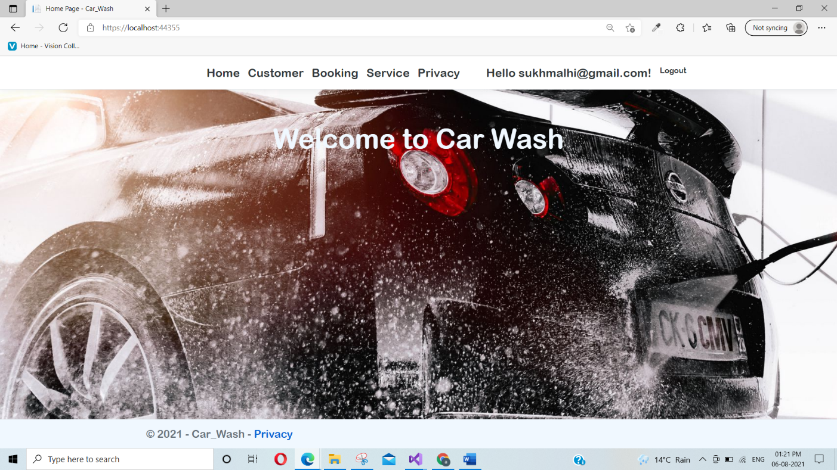

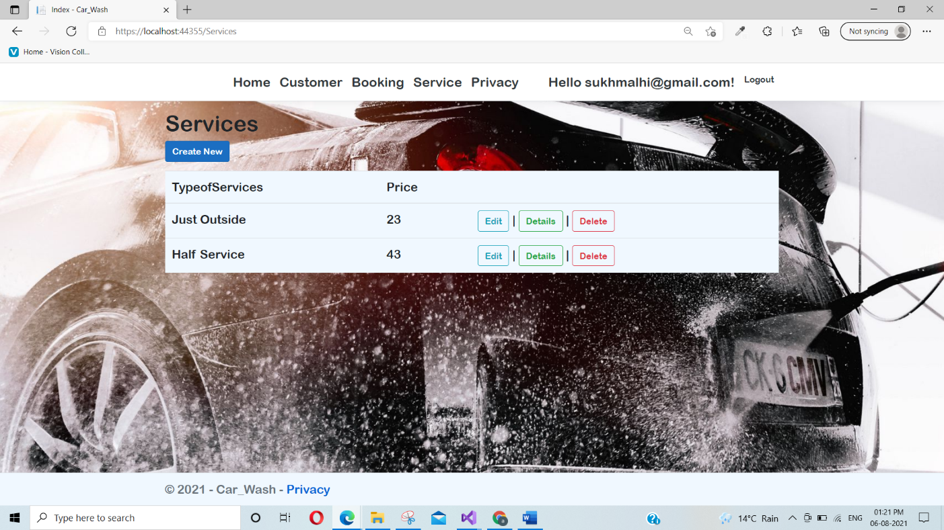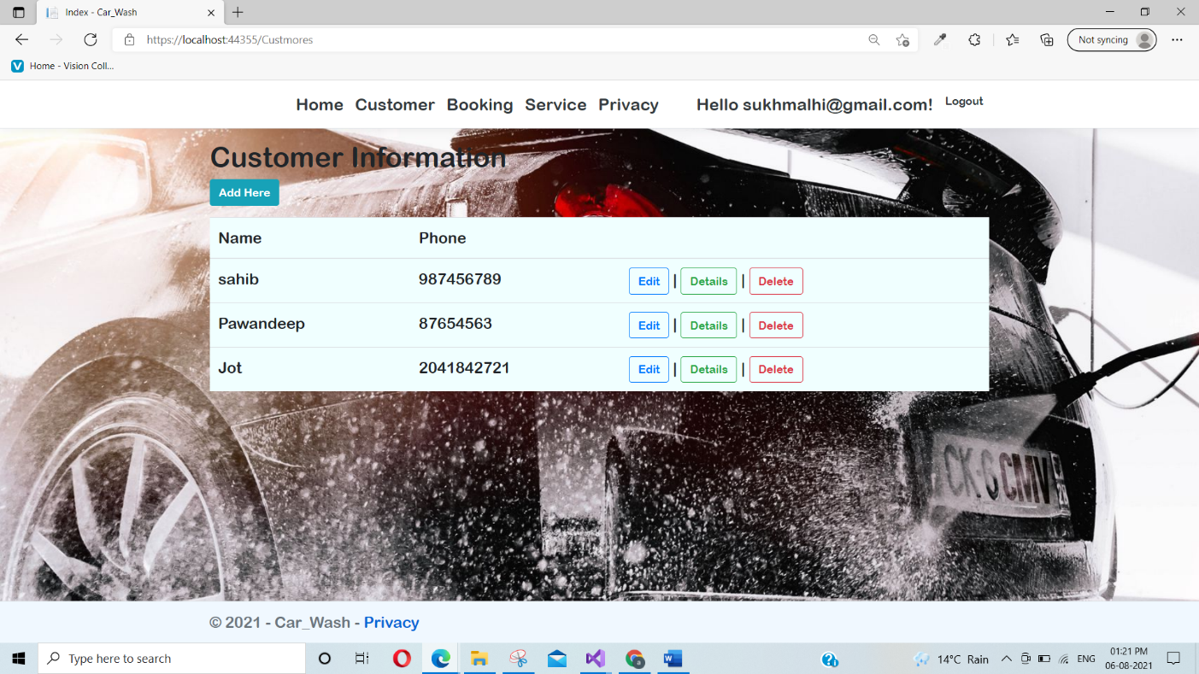

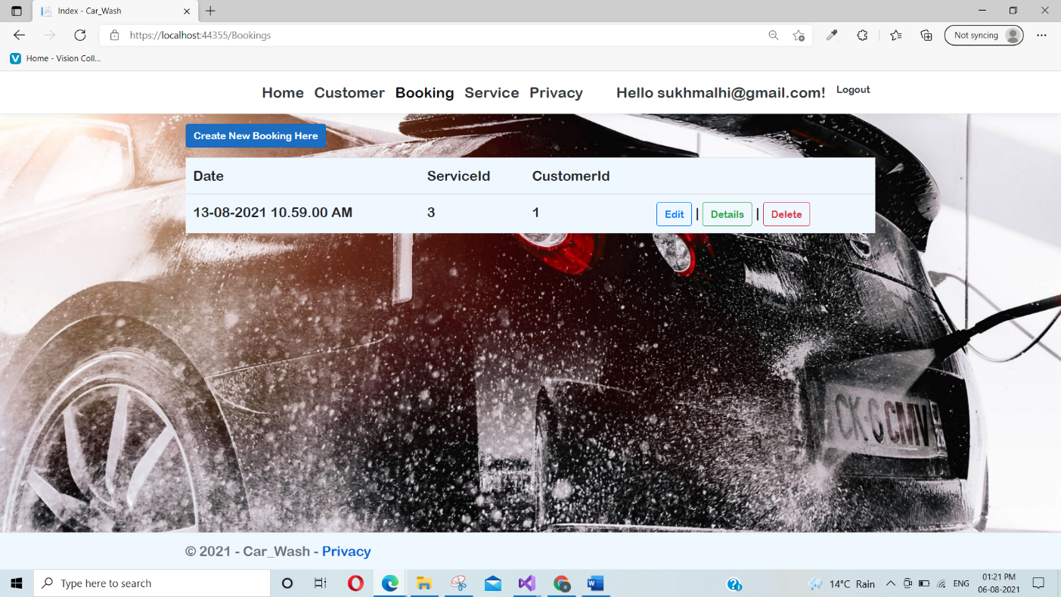

## System Usability Testing

### Testing

**Tester 1**

|  |  |  |  |  |  |  |
| --- | --- | --- | --- | --- | --- | --- |
| **Tester –1** | | **Answer Scale** | | | | |
| **No.** | **Question** | **Strongly Disagree (1)** | **Disagree (2)** | **Normal (3)** | **Agree (4)** | **Strongly Agree (5)** |
| 1 | I think that I would like to use this system frequently |  |  |  |  |  |
| 2 | I found the system complex |  |  |  |  |  |
| 3 | I thought the system was easy to use |  |  |  |  |  |
| 4 | I found the various functions in this system were well-integrated |  |  |  |  |  |
| 5 | I thought there was too much inconsistency in this system |  |  |  |  |  |
| 6 | I would imagine that most people would learn to use this system very quickly |  |  |  |  |  |
| 7 | I felt very confident using the system |  |  |  |  |  |

**Tester-2**

|  |  |  |  |  |  |  |
| --- | --- | --- | --- | --- | --- | --- |
| **Tester –2** | | **Answer Scale** | | | | |
| **No.** | **Question** | **Strongly Disagree (1)** | **Disagree (2)** | **Normal (3)** | **Agree (4)** | **Strongly Agree (5)** |
| 1 | I think that I would like to use this system frequently |  |  |  |  |  |
| 2 | I found the system complex |  |  |  |  |  |
| 3 | I thought the system was easy to use |  |  |  |  |  |
| 4 | I found the various functions in this system were well-integrated |  |  |  |  |  |
| 5 | I thought there was too much inconsistency in this system |  |  |  |  |  |
| 6 | I would imagine that most people would learn to use this system very quickly |  |  |  |  |  |
| 7 | I felt very confident using the system |  |  |  |  |  |